CS 590 Module Six Assignment2
1. Identify Logical Entities Within the Data Sets
The four CSV files were analyzed to identify the main entities in the Child Nutrition data. The logical entities identified were:
- FoodCategory
- FoodDescription
- GPCCategory
- Weight
Each entity represents a separate part of the data and contains its own properties. These entities were selected because they are connected through shared codes and can be modeled effectively in a graph database.
2. Develop a Graph Schema
A graph schema was developed in Neo4j using nodes, relationships, and properties.
Nodes:
- FoodCategory
- FoodDescription
- GPCCategory
- Weight
Relationships:
- FoodDescription → BELONGS_TO → FoodCategory
- FoodDescription → HAS_WEIGHT → Weight
- FoodDescription → CLASSIFIED_AS → GPCCategory
Each node contains values from the CSV files such as codes, descriptions, and weight values. This schema allows the Child Nutrition data to be stored as connected graph data rather than separate relational tables.
3. Create a Graph Representing the Schema
A visual graph diagram was created to represent the schema. The graph includes four node types and the relationships between them. FoodDescription acts as the central node and connects to FoodCategory, GPCCategory, and Weight. This design makes the data easier to visualize and easier to query using Neo4j.
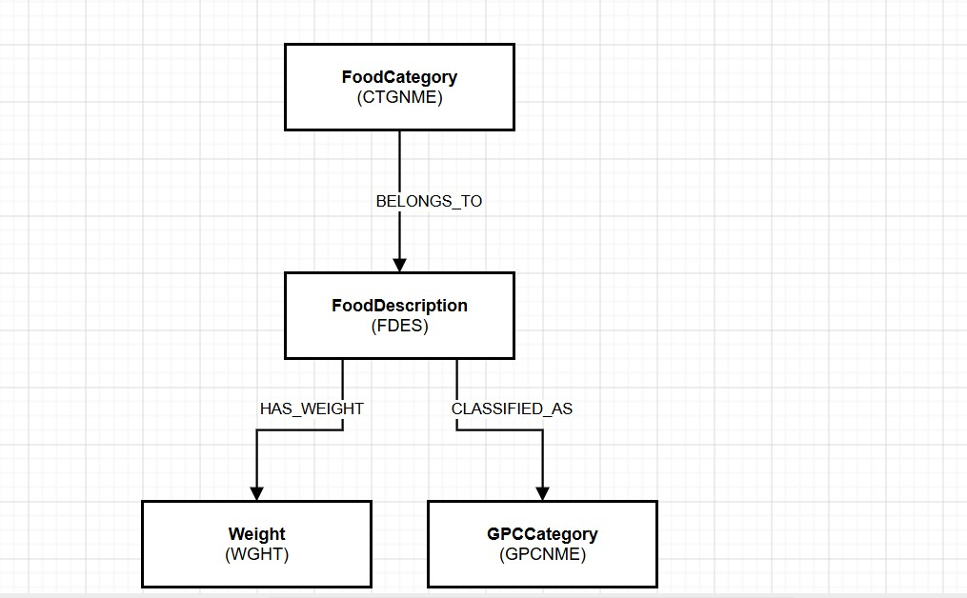
4. Implement the Graph Schema
The graph schema was implemented in Neo4j Browser by importing the four CSV files and creating nodes for each entity.
After importing the data, relationships were created between the nodes using matching values from the datasets. This created a connected graph database structure representing the Child Nutrition data.
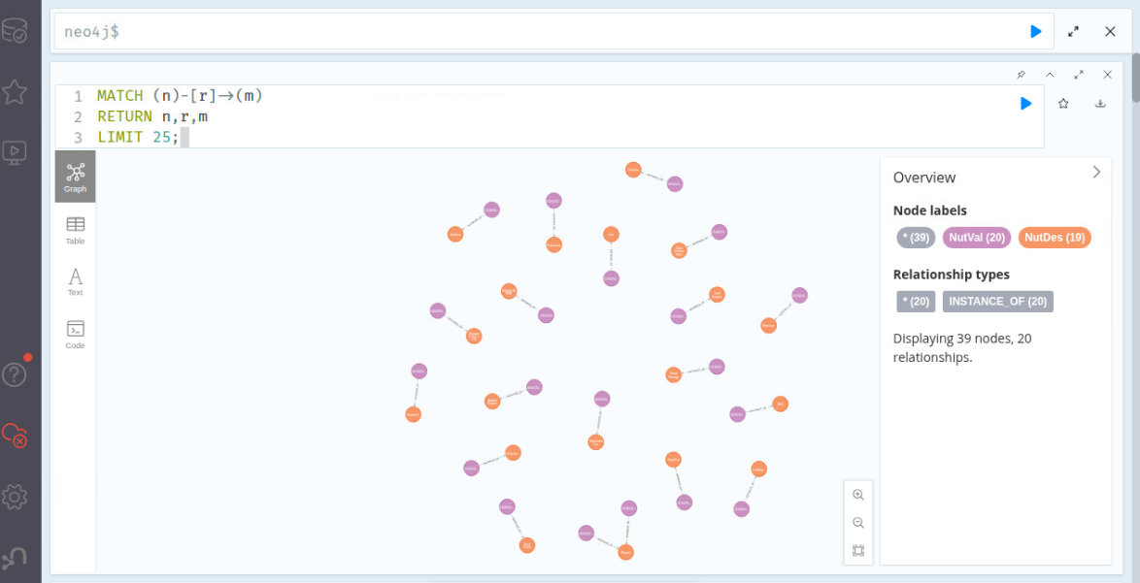
5. Perform Extract, Transform, and Load (ETL) Processes
ETL was completed using the provided CSV files.
Extract: Data was extracted from:
- Module_Six_CTGNME.csv
- Module_Six_FDES.csv
- Module_Six_GPCNME.csv
- Module_Six_WGHT.csv
Transform: CSV columns were mapped to Neo4j node properties. Values were preserved while adjusting the data format for Neo4j import.
Load: The transformed data was loaded into Neo4j using LOAD CSV queries, creating nodes and relationships.
This ETL process successfully moved the Child Nutrition data into a graph database structure.
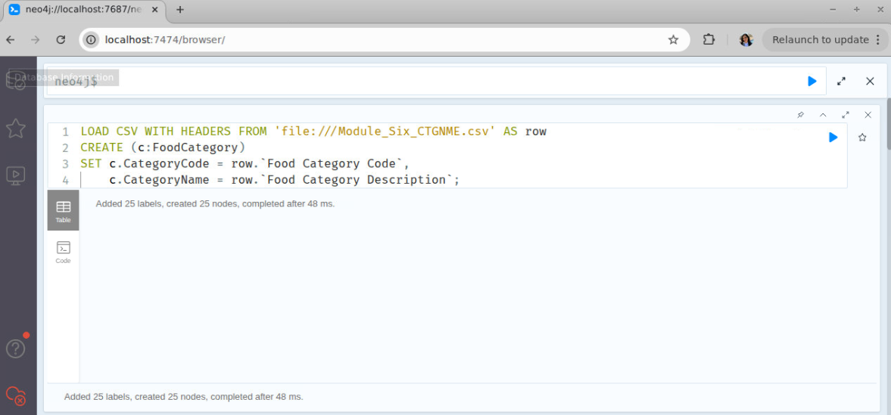
6. Execute the Provided Cypher Queries to Verify Integration
The provided Cypher queries were executed in Neo4j Browser to verify successful integration. These queries counted the imported nodes and confirmed that data was successfully stored in Neo4j. A verification query returned GPCCategory_Count = 131, confirming successful import of the GPC category data. The query results verified that the graph schema and ETL process were completed successfully.
